**Q[1] What is software? What is software engineering?**

**Ans:-**

**Software:** Software refers to a set of instructions or programs that tell a computer how to perform specific tasks. It encompasses all the digital data that can be stored and executed by a computer, including applications, operating systems, scripts, and more. Software is a critical component of modern computing systems, enabling them to perform a wide range of functions and tasks.

There are two main categories of software:

1. **System Software:** This type of software is responsible for managing the hardware components of a computer and providing a platform for other software to run. Examples include operating systems (e.g., Windows, macOS, Linux) and device drivers.
2. **Application Software:** Application software is designed to perform specific tasks or applications for end-users. Examples include word processors, web browsers, games, and productivity tools.

**Software Engineering:** Software engineering is a systematic and disciplined approach to the development, maintenance, and testing of software. It involves applying engineering principles to software development, with the goal of producing high-quality, reliable, and efficient software systems.

Key aspects of software engineering include:

1. **Requirements Analysis:** Understanding and defining the requirements of the software based on the needs of users and stakeholders.
2. **Design:** Creating a blueprint or plan for the software that outlines its structure, components, and interactions.
3. **Implementation:** Writing the actual code and building the software based on the design specifications.
4. **Testing:** Verifying that the software functions as intended and identifying and fixing any defects or bugs.
5. **Maintenance:** Making updates, enhancements, and fixes to the software throughout its lifecycle to ensure continued functionality and relevance.
6. **Project Management:** Managing the development process, including scheduling, budgeting, and coordinating the work of the development team.

Software engineering aims to apply engineering principles to the entire software development process, emphasizing the importance of systematic approaches, documentation, and collaboration among team members. The goal is to produce software that meets user needs, is reliable, scalable, and can be maintained and updated effectively over time.

Top of Form

**Q[2] Explain types of software.**

**Ans :-**

Software can be categorized into several types based on its functionality, purpose, and use. Here are some common types of software:

1. **System Software:**
   * **Operating Systems:** Examples include Windows, macOS, Linux, and Android. Operating systems manage hardware resources and provide services for computer programs.
   * **Device Drivers:** These are software components that allow the operating system to communicate with hardware devices like printers, graphics cards, and storage devices.
2. **Application Software:**
   * **Productivity Software:** Includes word processors (e.g., Microsoft Word), spreadsheets (e.g., Microsoft Excel), and presentation software (e.g., Microsoft PowerPoint).
   * **Web Browsers:** Software like Chrome, Firefox, Safari, and Edge that allows users to access and interact with content on the internet.
   * **Media Players:** Software for playing audio and video files, such as VLC Media Player or Windows Media Player.
   * **Graphics Software:** Tools like Adobe Photoshop for image editing or AutoCAD for computer-aided design.
   * **Communication Software:** Email clients (e.g., Outlook), messaging apps (e.g., WhatsApp), and video conferencing tools (e.g., Zoom).
3. **Development Software:**
   * **Integrated Development Environments (IDEs):** Software like Visual Studio, Eclipse, or IntelliJ IDEA that provides tools for software developers to write, test, and debug code.
   * **Compilers and Interpreters:** Tools that translate high-level programming languages into machine code. Examples include GCC (GNU Compiler Collection) and Python interpreter.
4. **Security Software:**
   * **Antivirus Software:** Programs like Norton, McAfee, and Avast that protect computers from malware, viruses, and other security threats.
   * **Firewalls:** Software that monitors and controls incoming and outgoing network traffic to prevent unauthorized access. Examples include Windows Firewall.
5. **Utility Software:**
   * **Backup Software:** Tools that automate the process of backing up data, such as Acronis True Image or Time Machine.
   * **File Management Utilities:** Programs for organizing, copying, and moving files, like File Explorer on Windows or Finder on macOS.
   * **Disk Cleanup Tools:** Software that helps optimize storage space by removing unnecessary files.
6. **Business Software:**
   * **Enterprise Resource Planning (ERP) Software:** Integrated software suites for managing business processes, such as SAP or Oracle ERP.
   * **Customer Relationship Management (CRM) Software:** Tools like Salesforce or HubSpot that help businesses manage customer relationships and interactions.

These categories are not mutually exclusive, and many software applications may fall into multiple types depending on their features and functionalities. The classification of software types helps users, developers, and industry professionals understand and organize the diverse landscape of software applications.

Top of Form

**Q [3] What is SDLC? Explain each phase of SDLC.**

**Ans :-**

**SDLC (Software Development Life Cycle):** SDLC, or Software Development Life Cycle, is a systematic process used by software developers to design, develop, test, and deploy high-quality software. It is a framework that outlines the tasks and activities involved in each phase of software development, from the initial concept to the final product. The goal of SDLC is to produce software that meets or exceeds customer expectations, is delivered on time and within budget, and is maintainable and scalable.

The SDLC typically consists of several phases, each with its own set of activities and deliverables. The specific phases can vary slightly depending on the methodology used, but a common model includes the following:

1. **Requirements Gathering and Analysis:**
   * **Objective:** Understand and document the software requirements by consulting with stakeholders, including end-users, clients, and business analysts.
   * **Activities:**
     + Conduct interviews, surveys, and workshops.
     + Identify system functionalities and constraints.
     + Document use cases, user stories, and system requirements.
   * **Deliverables:** Requirement specification document, use cases, and functional specifications.
2. **System Design:**
   * **Objective:** Create a blueprint for the system based on the requirements gathered in the previous phase.
   * **Activities:**
     + Architectural design: Define the overall structure and components of the system.
     + High-level design: Specify modules, interfaces, and data flow.
     + Detailed design: Create detailed specifications for each module.
   * **Deliverables:** System architecture document, high-level design document, detailed design document.
3. **Implementation (Coding):**
   * **Objective:** Translate the design specifications into actual code.
   * **Activities:**
     + Write and compile code according to the design.
     + Perform unit testing to identify and fix defects.
     + Develop and integrate individual modules.
   * **Deliverables:** Executable code, unit test cases, and documentation.
4. **Testing:**
   * **Objective:** Verify that the software functions correctly and meets the specified requirements.
   * **Activities:**
     + Develop and execute test cases.
     + Identify and fix defects.
     + Conduct system testing, integration testing, and user acceptance testing.
   * **Deliverables:** Test plans, test cases, defect reports, and validated software.
5. **Deployment (or Implementation):**
   * **Objective:** Release the software for production use.
   * **Activities:**
     + Plan and execute deployment activities.
     + Train end-users and support teams.
     + Monitor and address any issues during the initial rollout.
   * **Deliverables:** Deployed software, user manuals, and training materials.
6. **Maintenance and Support:**
   * **Objective:** Address issues, enhance features, and ensure ongoing system functionality.
   * **Activities:**
     + Fix defects and bugs reported by users.
     + Implement updates and enhancements.
     + Provide ongoing support and maintenance.
   * **Deliverables:** Updated software versions, maintenance documentation.

The SDLC is an iterative process, and feedback from each phase can lead to revisions and improvements in subsequent iterations. Various methodologies, such as Waterfall, Agile, and Spiral, implement SDLC in different ways to suit the project's requirements

Q [4] What is DFD? Create a DFD diagram on Flipkart.

Ans :-

DFD stands for Data Flow Diagram, which is a graphical representation of how data moves through a system. It's a visual tool that helps to illustrate the flow of information within a system and how different components interact with each other.

Creating a DFD for a complex system like Flipkart can be quite detailed, and it typically involves breaking down the system into different processes, data stores, data flows, and external entities. However, I can provide a simplified DFD for Flipkart, highlighting some key components and their interactions. Please note that this will be a high-level overview, and a complete DFD for a system like Flipkart would be much more detailed.

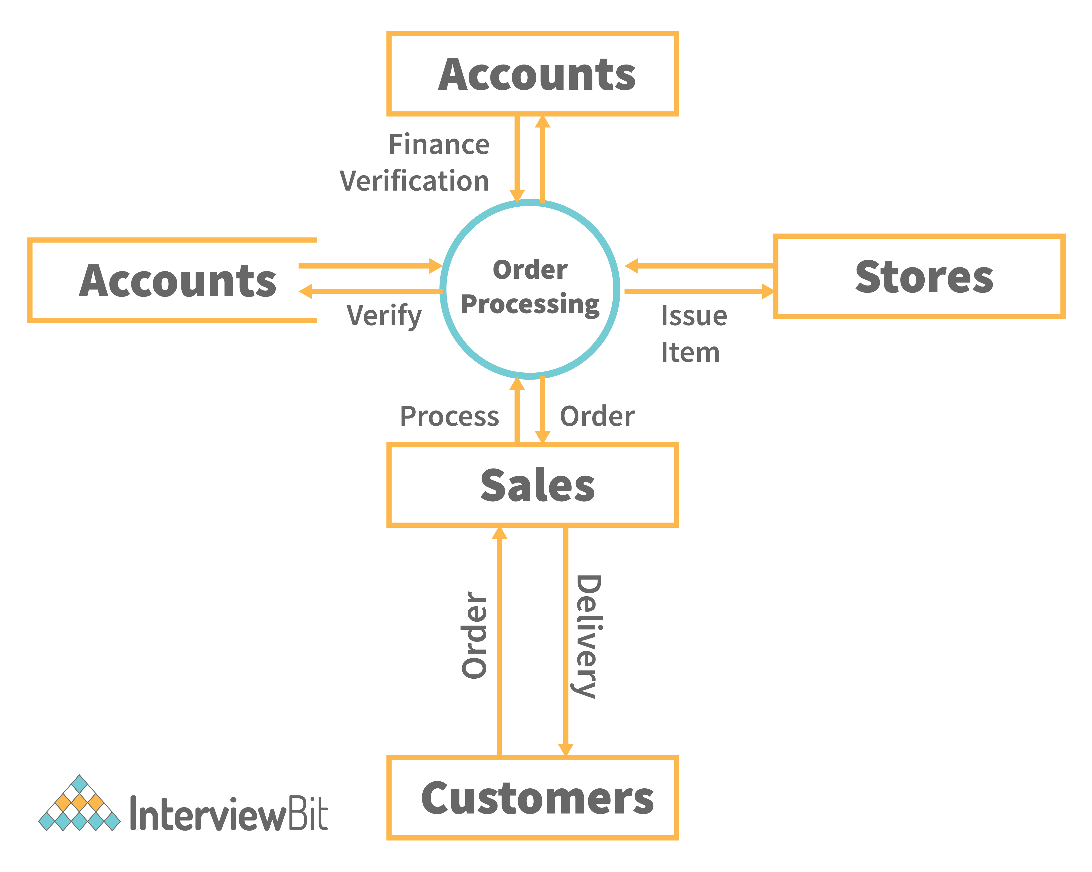



**SQ [5]**  What is Flow chart? Create a flowchart to make addition of two numbers.

Ans :-

A flowchart is a diagram that represents a process, showing the steps involved and the order in which they occur. It uses different shapes to represent different types of steps or actions and arrows to indicate the flow or sequence of the process. Here's a simple flowchart for adding two numbers:

**Explanation:**

1. **Start:** The process begins here.
2. **Enter Number A:** User inputs the first number (Number A).
3. **Enter Number B:** User inputs the second number (Number B).
4. **Add Numbers A and B:** The two input numbers (A and B) are added together.
5. **Display Result:** The result of the addition is displayed.
6. **End:** The process ends.

Each rectangular box represents a process or action, and the arrows indicate the flow or sequence of the process. The diamond-shaped box represents a decision point, but in this simple addition example, there are no decisions to be made. The flowchart starts with "Start," and the process proceeds through the steps until it reaches the "End."

Top of Form

+-------------------------+

| Start |

| |

V |

[Enter Number A]---------->[Enter Number B]

| |

V |

| |

+-------------------------+

|

V

|

[Add Numbers A and B]----->[Display Result]

|

V

|

+-------------------------+

|

V

|

[End]

Q [6] What is Use case Diagram? Create a use-case on bill payment on paytm.

**Ans :-**

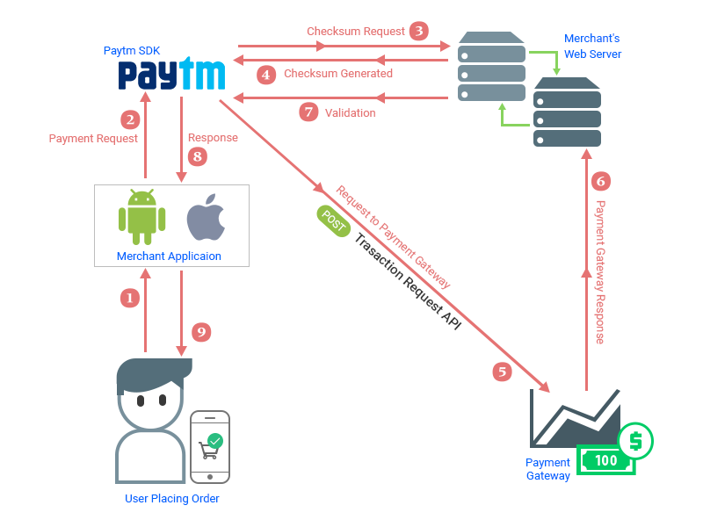

**Explanation:**

1. **User (Paytm Account):** The user is an actor who interacts with the Paytm system. This actor has a Paytm account and wants to perform a bill payment.
2. **Bill Payment Use Case:** This represents the main functionality that the user wants to perform. It involves interacting with the Paytm system to make a bill payment. The details of the bill payment, such as the type of bill (electricity, water, mobile service), the amount, and any other relevant information, are part of this use case.
3. **External System (Electricity, Water, Mobile Service):** These are external actors that are not part of the Paytm system but interact with it. For bill payment, the user may be paying bills to external systems such as electricity providers, water utilities, or mobile service providers. These external systems are connected to the Paytm system to facilitate bill payments.

In this use case diagram, the focus is on the interaction between the user and the Paytm system for the specific functionality of bill payment. Use case diagrams help to understand the system's functionality from a high-level perspective and identify the different actors involved in the system.